System Design Document

Project: <project name>

By: <team>

# Architecture

## Web Framework

*Provide an explanation for the Django framework. You may reuse the image below or replace by another one of your choice.*

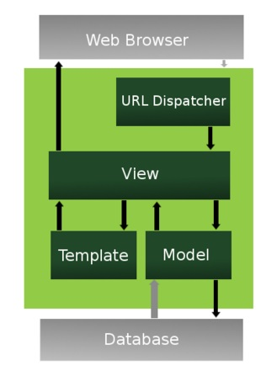

Xxx

# Data Access Design

## Model Design (Data Model)

*This is the “model” part of the MVC pattern.*

*We refine the high-level business domain model and create a detailed data model with all the entities that we will need to store in the database, with their attributes and relationships.*

## Functional Decomposition

*Select the key entities in the data model. From the user stories identify the types of functions needed on each entity, and which users will be performing them. This will provide you with a basis for identifying the Views that you will need.*

## Database Investigation

*List which database management systems you investigated, and which is more appropriate for your web app. Justify your decision.*

# Security Design

## Framework Security

Which security features are provided by the web framework, which ones will you use?

## Security Mechanisms

How will you implement each of the security mechanisms (if provided by framework, how will you use them, e.g. which settings, etc.)

## User Roles and Permissions

# User Interface Design

## View Design (UI List)

*This is the “view” part of the MVC pattern.*

*List the user interfaces needed to perform each user story.*

### User Story 1

### User Story 2

## UI Design

Record palette, fonts, look and feel, bootstrap used, etc. for your web app.

Include a wireframe or mockup for the landing page to illustrate the style you are aiming for.